Họ và tên: Lê Bá Khánh Trình

MSSV: 6151071108

Lớp: CNTT K61

**(3) Oracle Wildcard special Operators**

1. Write a Oracle SQL statement to get the first date of the current month. 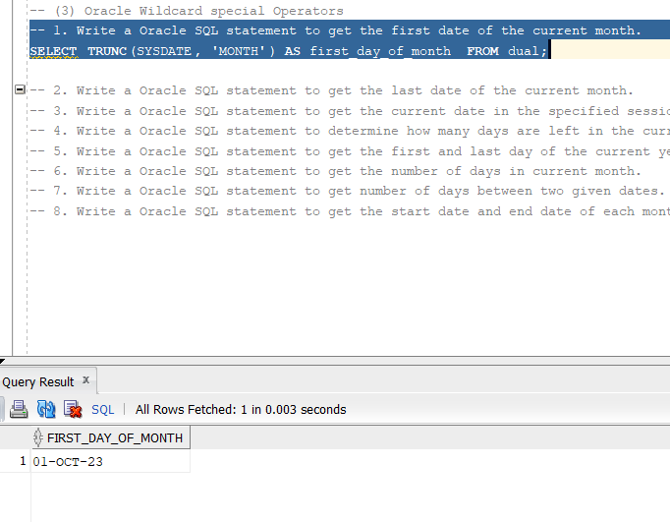

2. Write a Oracle SQL statement to get the last date of the current month. 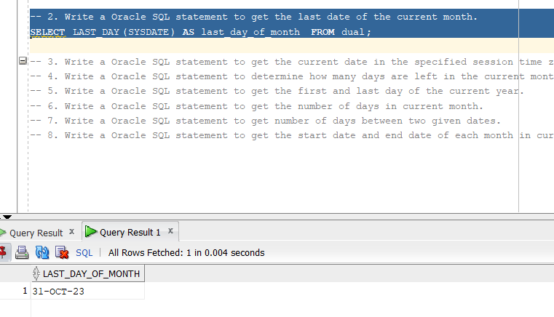

3. Write a Oracle SQL statement to get the current date in the specified session time zone. 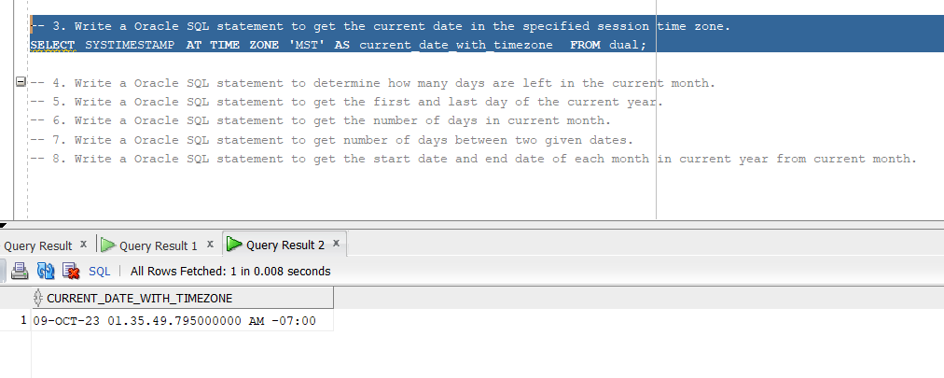

4. Write a Oracle SQL statement to determine how many days are left in the current month. 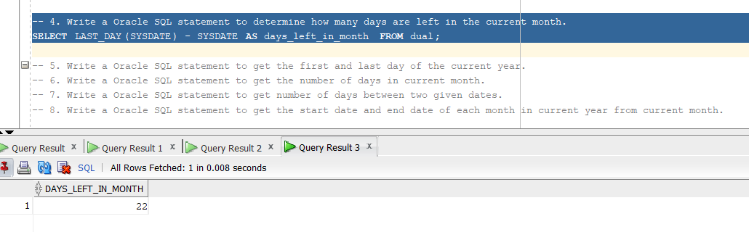

5. Write a Oracle SQL statement to get the first and last day of the current year. 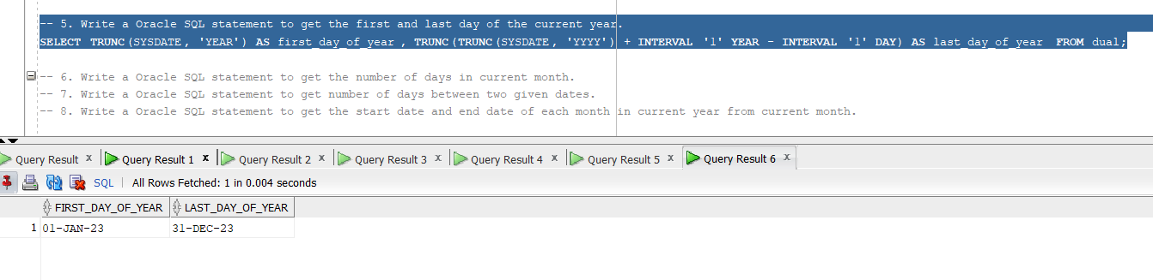

6. Write a Oracle SQL statement to get the number of days in current month. 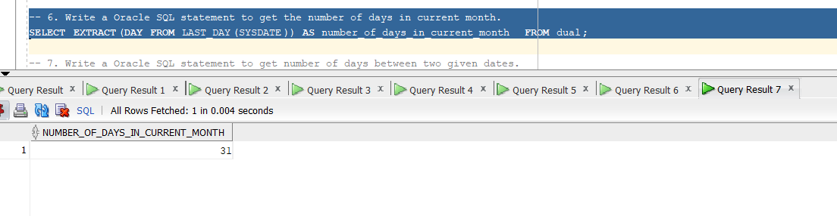

7. Write a Oracle SQL statement to get number of days between two given dates. 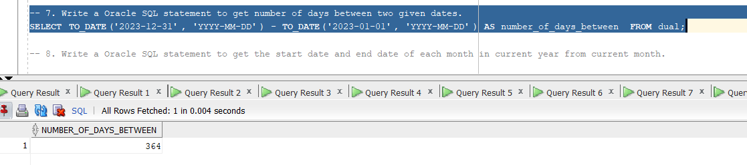

8. Write a Oracle SQL statement to get the start date and end date of each month in current year from current month. 